Eyeconic - Glasses Shop Management System

Use-Case-Realization Specification:M30-Add Sprays

Version <1.0>

Revision History

|  |  |  |  |
| --- | --- | --- | --- |
| **Date** | **Version** | **Description** | **Author** |
| 05/11/2019 | 1.0 | The first version of add Sprays | Nguyễn Tuấn Anh |

Table of Contents

1. Introduction 4

1.1 Purpose 4

1.2 Scope 4

1.3 Definitions, Acronyms, and Abbreviations 4

1.4 References 4

1.5 Overview 4

2. Flow of Events—Design 4

3. Derived Requirements 6

Use-Case-Realization Specification: Add Sprays

# Introduction

## Purpose

This document describes how the Add Sprays use case is realized within the design model.

## Scope

This document applies to the Eyeconic - Glasses Shop Management System.

## Definitions, Acronyms, and Abbreviations

None.

## References

None.

## Overview

In the following section, Use-Case Realization Specification of the Add Sprays use-case of the Eyeconic is provided in detail. The first section is a textual description of the Use-Case specification. The following section contains sequence diagrams describing how the use case is realized in terms of collaborating objects. The third section includes class diagrams with relationships that participate in the realization of the use case. The last section is an analysis of all requirements, such as non-functional requirements, on the use-case realization that are not considered in the design model, but that need to be taken care of during implementation.

# Flow of Events—Design

**2.1. Use-Case Specification**

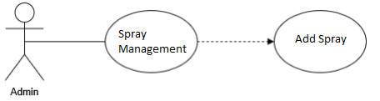

|  |  |  |  |
| --- | --- | --- | --- |
| **Name** | | | Add Sprays |
| **Brief Description** | | | Administrator adds new sprays into the website. |
| **Actors** | | | Administrator |
| **Flow of Events** | | | |
| **Basic Flow** | | | |
| Step 1: Click add a new Sprays button in Sprays management.  Step 2: Fill new Spray’s information.  Step 3: Set the database parameters of new Sprays.  Step 4: System displays new Sprays in the website. | | | |
| **Alternative Flows** | | | |
| **Title** | | **Description** | |
| Invalid information entered | | 1. Administrator enters invalid information.  2. System displays information with appropriate message to correct invalid information. | |
| **Pre-Conditions** | | | |
| The added Sprays had not existed in the database before. | | | |
| **Post-Condition**  Administrator checks the database and the website to ensure that the new Sprays is added successfully. | | | |
| **Title** | **Description** | | |
| Success | Sprays is added to database. | | |
| Failure | The admin is unable to add new Sprays to database for one or more reasons and an error is prompt. | | |
| **Extension Points** | None | | |

**2.2. Sequence Diagram**

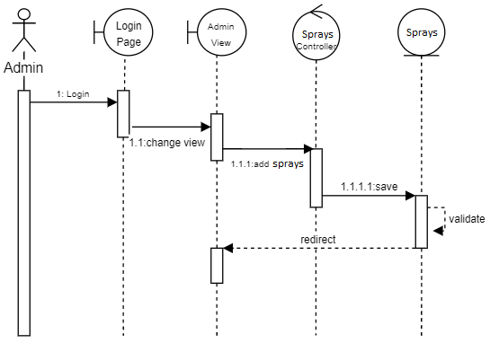

**2.3. Class Diagram**

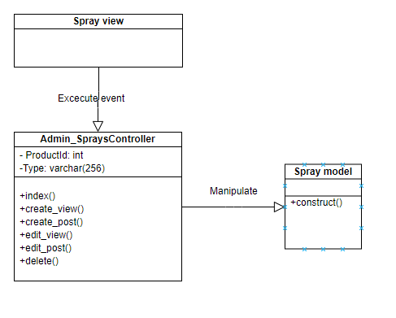

# Derived Requirements

None.